Clemson University
Active Contours Without Edges.
Assignment 2, ECE 877
Ujwal C Naik
Assignment Number 2

Report for the 2nd assignment for Computer Vision – ECE 877.

Introduction:
In this assignment we have implemented a segmentation method developed by Dr. Tony F. Chan and Dr. Luminita Vese. In this implementation most of the short comings experienced in the active-snakes model have been overcome and it performs better than thresholding and gradient based segmentation methods. The results produced are much better in case of colored images.
The model works on the assumption that the initial contour is either completely surrounding the object that we wish to segment or is completely contained within it. Chan-Vese propose segmenting images using a model of the interior and exterior and the level set function is used to represent the curve of the interior region. The aim of the algorithm is to minimize the energy functional associated with the contour bounding the area of interest.

Method:
The aim of the Chan-Vese paper is to use the level set function to represent a curve of the interior region and minimize the energy functional associated with the contour. The energy functional that we wish to minimize is given as :
The method followed for implementation of the algorithm is as follows:
- Load the image and compute the value for Φ, using the computed value of Φ initialize Γ which forms the initial contour.
- Once the contour is marked on the image we use Φ to calculate the values of ci and co.ci is the average of the intensities inside the contour Γ and co is the average of the intensities outside the contour Γ.
- Now we calculate the gradient magnitude of Φ and using the x and y gradients of Φ along with the gradient magnitude we are able to calculate the divergence of the gradient of Φ with respect to the gradient magnitude.
- We then calculate the value of delta Φ using the following formula:
Here v, µ, λi and λo are constants
- Using the new delta Φ value we update the value of Φ, by adding the initial value of Φ with delta Φ.
- Using the new value of Φ we again recalculate the contour bounding Φ and the values for ci and co which are the averages of the intensities inside and outside the contour respectively.
- Steps 3-6 are performed iteratively until convergence is achieved.

Algorithm:
The algorithm for template matching is as follows:
- Load the image.
- Initialize the Γ and Φ. Γ is the contour of the region and we use Φ to calculate the value of Γ.
- Using Φ calculate the values of ci and co which are the averages of the inner and outer intensities respectively.
- Compute the divergence and the magnitude of the gradient of Φ.
- Using the Euler Lagrange equation, calculate the value of delta Φ.
- Update the value of Φ using the newly calculated delta Φ. Using the updated value of Φ calculate the new values of Γ and ci and co. Reinitialize Φ by computing the chamfer distance.
- Steps 3-6 are repeated iteratively until the boundary stops moving or the number of iterations specified by the user has been performed.

RESULTS
Result for the fruitfly image
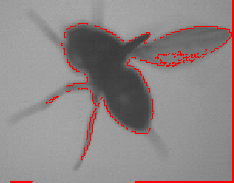

Results obtained on hand images:
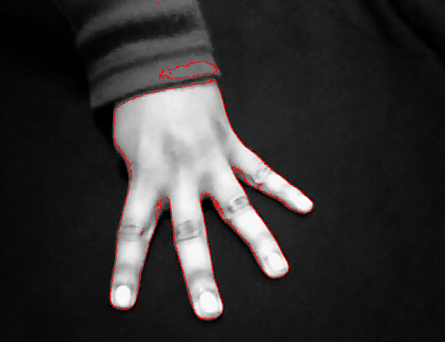

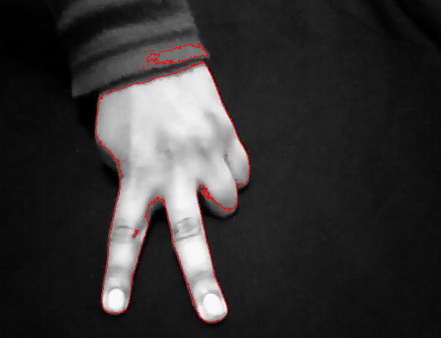

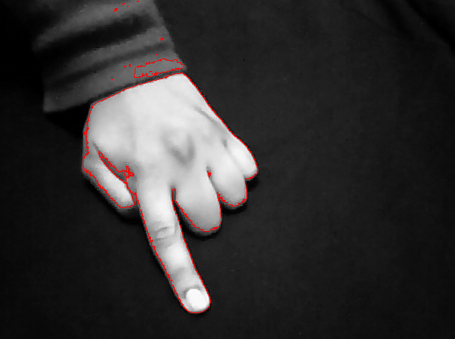
Conclusion
It can be observed from the results that the algorithm works very well on a variety of images. Its performance is more likely to be much better than thresholding and gradient based algorithms and when working on color images it should be able to segment the region of interest more effectively than the thresholding and gradient based methods.
However, the algorithm is also much slower than the thresholding and gradient based algorithms and when tested on a larger image or an image needing more iterations it performs fairly slowly.
.

